1. **DAX formulas:**

* Calendar Table:
  + AvailabilityRate = DIVIDE([Total Active Days], [Total_Days_Listed])
  + Average Price = AVERAGE('Calendar'[price])
  + Total Active Days = CALCULATE(COUNTROWS('calendar'),calendar[available] = TRUE())
  + Total_dayS_listed = COUNTROWS('Calendar')
  + Total_Revenue = SUM('calendar'[adjusted_price])
* Listings Table:
  + Total Listings = DISTINCTCOUNT('Listings'[listing_id])
* Review Table:
  + Review Count = COUNTROWS('reviews')
* Scenario Price = 'calendar'[Average Price] * SELECTEDVALUE('Seasonal Multiplier'[Seasonal Multiplier], 1)
* Seasonal Multiplier Value = SELECTEDVALUE('Seasonal Multiplier'[Seasonal Multiplier], 1)
* Occupancy Rate Value = SELECTEDVALUE('Occupancy Rate'[Occupancy Rate], 0.8)
* Projected Revenue = SUMX(

'Calendar',

'Calendar'[price] *

SELECTEDVALUE('Occupancy Rate'[Occupancy Rate], 0.8) *

SELECTEDVALUE('Seasonal Multiplier'[Seasonal Multiplier], 1)

)

1. **Data Model diagram**

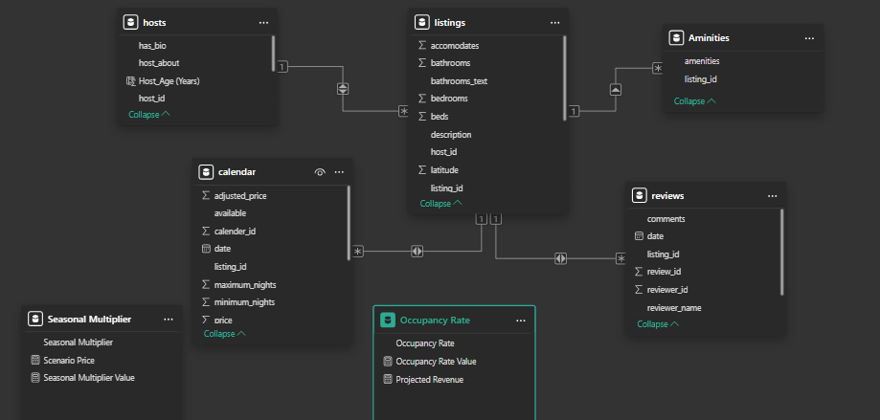

* Key Relationships:
  + calendar[listing_id] → listings[listing_id]
  + listings[host_id] → hosts[host_id]
  + reviews[listing_id] → listings[listing_id]
  + Aminities[listing_id] → listings[listing_id]

1. **“What-If” parameter setup.**

* **Occupancy Rate Table:** 0 to 1 (step 0.05)
  + Occupancy Rate Value = SELECTEDVALUE('Occupancy Rate'[Occupancy Rate], 0.8)
  + Occupancy Rate = GENERATESERIES(0, 1, 0.05)
  + Projected Revenue =

SUMX(

    'Calendar',

    'Calendar'[price] *

    SELECTEDVALUE('Occupancy Rate'[Occupancy Rate], 0.8) *

    SELECTEDVALUE('Seasonal Multiplier'[Seasonal Multiplier], 1)

)

* **Seasonal Multiplier:** 0.8 to 1.5 (step 0.05)
  + Scenario Price =

'calendar'[Average Price] * SELECTEDVALUE('Seasonal Multiplier'[Seasonal Multiplier], 1)

* + Seasonal Multiplier = GENERATESERIES(0.8, 1.5, 0.05)
  + Seasonal Multiplier Value = SELECTEDVALUE('Seasonal Multiplier'[Seasonal Multiplier], 1)